Society Year  Region(s)  Location (City)  Host Chapter  Dates | 2026-2027  II  Cardigan, Prince Edward Island  New Brunswick / Prince Edward Island  August 28-30, 2026

- General Attendance
  - Total CRC Attendance: 193 (A Region II Record!!)

  - Accommodations:
    - The CRC was held at: Rodd Brudenell River Resort
    - CRC activities were:
      - Thursday
        - Hospitality Suite (plus Friday and Saturday Night)
      - Friday
        - Business Meeting #1
        - Caucus Session #1
        - Industry Roundtable
        - Presidential Lunch
        - Welcome Party
      - Saturday
        - ASHRAE 101 Presentation, Treasurer Training
        - Caucus Session #2
        - Workshops (morning): CTTC, YEA, SA, MP, RP, History
        - Scavenger Hunt
        - Awards luncheon
        - Workshops (afternoon): CTTC, YEA, SA, MP, RP, GAC, History/Communications
        - Chapter Operations
        - Fire in the Kitchen Dinner
      - Sunday
        - Business Meeting #2
        - CRC Debriefing
    - Hospitality Suite was located:
      - Roseneath Room at the resort. It was a separate room located away from the other hotel rooms. It had indoor space and a deck. It allowed the hospitality suite to operate until 1:00 am each evening.
    - Detailed Agenda
      - Below is the agenda developed prior to the CRC. There were some adjustments to the schedule after the CRC started.

  - CRC Preparation:
    - The CRC was managed as follows:
      - CRC General Chair(s): Dan Boudreau
      - Region DRC: Geneviève Lussier
      - Region RMCR: Ibrahim Semhat
      - Regional Nominating Member: Isabelle Lavoie

  - Protocol:
    - Registration:
      - A registration table was in the lobby of the hotel, right as you come in the front door. It was very easy to see and get signed up.
    - Visiting officer/staff recognition:
      - All CRC attendees were picked up at the airport. That included me being picked up by the CRC General Chair’s wife at 12:10 AM!
      - Visiting officers, staff and visiting DRCs were recognized with gifts at the Awards lunch on Saturday.
    - History Displays:
      - History displays were located in the room where the business room was held. They were easy to see, but it wasn’t noted that the displays were in the room.
      - Six (6) of nine (9) chapters had a history display.

  - Publicity options utilized to advertise the CRC include:
    - Region II Website (pointing to NB/PEI dedicated CRC page)
    - New Brunswick / Prince Edward Island Chapter dedicated CRC page.

  - General Comments:
    - A well-organized CRC, with a schedule that allowed time to get into details, and the overall feel of the CRC was not rushed or hurried.

- Business Sessions and Caucus
- Meeting Room Setup:
The meeting was set up in a U-shape, with four rows of 10 seats each behind the U. Four confidence monitors were placed at the center of the U, making the screens easy to see.

- Attendance
  - Business Session #1 (Friday) 63
  - Business Session #2 (Sunday) 43

- Caucus:
The caucus met on Friday from 10:15 AM – 12:00 PM and again on Saturday from 8:30 AM – 10:15 AM. Additional meetings were scheduled but not required. They caucus completed their business.

- Business Sessions:
  - Business Session #1 (Friday)
    - Call to Order & Value Statement
    - Introductions and Ice Breaker – Self-introductions were utilized. In addition to stating your name and chapter affiliation, each person listed their favorite sport to play or watch. Golf was very popular, but there were also many with cricket, and even one had curling!
    - Appointment of the CRC recording secretary – Tom Pollard
    - Approval of CRC 2025 Hamilton CRC Minutes – Approved with no changes.
    - A summary of the CRC events was made by the CRC General Chair.
    - The RMCR provided a report of 2025 Region II motions submitted to Society. See summary under RMCR report below.
    - One motion was preread. This motion will be acted on during the Sunday business meeting.
    - Blake Ellis gave the Society officer report
    - Chapter Reports (Nine) were made – See summaries of each chapter below.
    - ASHRAE Staff Report (Craig Wright)
      - Craig presented the staff report, which was organized by the different departments.
      - Administrative – This was the first department, which is led by Craig! This group covers finance as well as other administrative areas, such as human resources and information technology.
      - Development – Includes Research Promotion (RP) and major gifts. The RP campaign almost raised US$3 million (US$2,968,199) during the last Society year!
      - Government Affairs – Led by Alice Yates, who is located in Washington DC. Craig stressed that people should subscribe to the biweekly government affairs newsletter and suggested they attend a government outreach event if their chapter organizes one.
      - Centralized Marketing – Led by Vanita Gupta. Craig pointed out that marketing is the members’ resource for any marketing-related information.
      - Member Services – Led by Lizzy Seymour. The primary contact for member issues. Members Council committees are the main committees that Member Services supports.
      - Publication and Education – Greg Martin is the interim director for Publication and Education. Mark Owen previously held this role and recently retired. ASHRAE is looking to split Mark’s job into two roles. One person as a Publication Director and the second as an Education Director. This role is responsible for all print and digital production and training, and for the management of intellectual property. Craig noted that volunteer experts create the content for both the publications and the education content that ASHRAE produces.
      - Technology – Led by Stephanie Reiniche, with a lot of experience on the staff. This group oversees the preparation of standards and guidelines and works with our Centers of Excellence for Decarbonization and Indoor Environmental Quality.
    - RVC and Regional Chairs Reports: See below for these reports.
    - The Region II 2025-2026 Financial Results and 2027-2028 Draft Budget were made. See the regional treasurer's report below.
    - Chapter Ops App update (Aaron Besseling)
      - Aaron Besseling provided a brief demo of the ChapterOps App that he helped develop.
  - Business Session #2 (Sunday)
    - Note: The announcement of the 2027 CRC was supposed to be in this business session, but it was moved to the break on Saturday afternoon.
    - There were delegates from three chapters that left early on Sunday morning, and a motion was made and passed to approve new delegates to replace the ones that left early. The new delegates had both voice and vote privileges on Sunday.
    - Presentation of workshop reports: Chapter Technology Transfer (CTTC), Student Activities (SA), Government Affairs (GA), Research Promotion (RP), Young Engineers in ASHRAE (YEA), Membership Promotion (MP), Communications, Historian, and Chapter Operations.
      - See the statistics table for counts of attendees at each workshop.
      - These were short presentations given to the entire business session that provided a summary of the activities in the workshops held the previous day. This allowed those in attendance to get some idea of what happened, as many of these were held concurrently.
      - Presentations were typically made by one of the chapter chairs who attended the workshop the previous day. They provided the attendance counts for the workshop and a high-level summary of the activities.
    - Report from Executive Session (Caucus)
      - The caucus was able to complete its work in two sessions.
      - It was also noted that the group was well prepared for their discussions.
    - CRC 2025 Hamilton Financial Report and Review
      - Total income CA$118,870.50, total expenses CA$118,589.74 (CA$280.76 in profit), which was noted as about perfect, as the CRC isn’t intended to be a money maker.
      - One of the items that the Hamilton Chapter noted was that food cost is high. For the 2025 CRC, this was CA$44,602 for just breakfast, lunch and snacks at the hotel. Both of the main dinners were off-site and not included in that total.
      - Dan Boudreaux (2026 CRC General Chair) led the audit of the previous year’s CRC financials. No issues were found.
    - CRC 2027 Montréal Presentation and Budget Approval
      - Isabelle Lavoie made a presentation for the 2027 CRC hosted by the Chapitre de Montréal. She is the co-chair with Nicolas Lemire.
      - Marriott Chateau Champlain is the hotel for the CRC. The hotel has been recently renovated, and rooms will be CA$309 per night plus tax. To select the hotel, a request for proposals (RFP) was sent to several hotels, and they received five (5) responses. To make the final selection, the CRC committee visited two (2) hotels.
      - CRC Program. The plan is to have something similar to this year, with a technical course under consideration. One of the social events will be held at the hotel due to the food-and-beverage minimum.
      - Adding a family program to the traditional companion program. It was noted that the expectations for watching (minding) the kids need to be clear regarding the responsibilities of the kids' program. It was also pointed out that allergens need to be considered.
      - Initial registration costs for break-even with CA$50,000 in corporate sponsors and attendance from the Hamilton Chapter.
        - Full CA$800
        - Partial CA$700
        - Companion CA$575
        - Kids CA$100
      - There was a motion made (and passed) to approve the DRAFT budget.
    - New Motions
      - Regional Motions (3)
        - Halifax – create a database of regional chapter awards. Passed 8-0-0, CNV.
        - Adjust the regional reimbursement policy to provide reimbursement for all positions that are required to attend events (Society and CRC) as a representative of the region. It is estimated that this could be a CA$10,000 budget impact. Passed – 9-0-0, CNV.
        - Toronto – If someone is the Chair or Vice Chair of a Society committee, they should be able to receive the same level of reimbursement as an RMCR. Passed – 9-0-0, CNV.
      - Society Motions (5)
        - Provide a credit card processor directly connected to ASHRAE Research Canada's Canadian Dollar Bank Account. Passed – 9-0-0, CNV.
        - Hamilton - That Society reimburse ASHRAE Region II for ChapterOps development in the amount of CA$7,526.63. Motion withdrawn. Action Item to Region II leadership to seek reimbursement.
        - Ottawa Valley – Data center certification program. Passed – 9-0-0, CNV.
        - Ottawa Valley – TC 101 webinar for introducing new members on how a TC is run, similar to a webinar that TC4.7 runs. Passed – 9-0-0, CNV.
        - Windsor – Incorporate old motions into the motion database. 2-7-0, CNV
        - Toronto – Modify checks so they can be deposited by banking applications for Canadian banks. Passed – 9-0-0, CNV.

    - DRC/RMCR/RVC Chapter Visits Schedule
      - Geneviève discussed the coordination of Sarah Maston’s visit.
      - Geneviève requested that the Regional Vice Chairs (RVCs) send her their plan to do chapter visits.
    - Updated Region II Manual of Operation presentation
      - Nicolas Lemire provided an update of his update of the Regional II operation manual, which he undertook to update the manual from ten (10 ) years ago.
      - The Assistant Regional Chair (ARC) is now tasked to update the manual on an annual basis.
    - Next CRCs dates:
      - Montréal: Aug. 20-22, 2027
      - Windsor: Aug. 18-20 or 25-27, 2028 (TBD)
      - Halifax: Aug. 17-19 or 24-26, 2029 (TBD)

- Regional Officer Reports - Summary highlights and challenges include:
  - DRC: (Geneviève Lussier)
    - 2025-2026
      - Region II had two (2) LeaDRS participants at the Winter and Annual Conferences.
      - Geneviève was super proud of the Regional ChapterOps App becoming a Society App!
      - New office hours would be set up for the next Society year, being held every two months.
    - 2026-2027:
      - Chapter visits are planned to Toronto, Hamilton & Windsor.
      - LeaDRS call for participants: Deadline – September 15.
      - Goal to finish updating the Region II Manual of Operation.
  - RMCR: (Ibrahim Semhat)
    - Status of 2025 Motions to Society
      - One (1) motion was defeated.
      - Three (3) motions were considered process motions.
      - One (1) motion passed the Board of Directors. The next step for that motion is a vote on the change in Society Bylaws.
    - Old Motions
      - Indigenous Smoke Motion – Under Review by Standards.
      - CTTC Centralized Training Motion – Defeated, but spurred a change.
    - Preread of 2026 Motions
      - One (1) motion was preread.
    - Members Council Update
      - One (1) proposal discussed was a distinguished chapter service award.
      - Approved new conferences, including Building Decarbonoization conference, Global TechCon North America (Ottawa), Data Center & AI Integration Conference
      - Reviewed the chapter health assessment and modernized it. The goal of the assessment is to provide help to chapters that need it.
  - ARC: (Nicolas Lemire)
    - Nicolas reported on the status of updating the Region Operations Manual.
  - Nominating: (Isabelle Lavoie)
    - The Nominating Committee completed its business on Saturday.
  - Government Affairs (GA): (Adrianne Mitani)
    - Planning government outreach events with every chapter.
    - All but two (2) chapters made PAR.
    - Visted Moncton and Montréal.
    - RVC Activities: Office hours were held monthly on a Friday, and a few office hours were held jointly with Region XI. Adrainne tried to send monthly emails. There was a shared drive for the chapter chairs containing relevant information.
    - Chapter Activities: provided a GA highlight from each chapter, including the federal Day on the Hill in Ottawa.
    - Goals: Achieve planning with all chapters, joint office hours with Region XI, get to the federal Day on the Hill, and try to help the GA staff understand Canadian issues.
  - Membership Promotion: (Badri Patel)
    - All chapters exceeded PAR!
    - Two visits were made last year by the RVC. Highlights were the Hamilton and Toronto Chapter MP events.
    - Four awards are given out by MP this year.
    - Looking to give out a regional award for the top MP chair in the region next year.
    - Virtual and in-person centralized training this year.
    - Québec and Toronto Chapter Chairs had great communication.
    - Goals: Virtual Centralized training is September 18th, visit three (3) chapters, grow chapter MP committees beyond chair and vice chair.
    - New membership model starts on July 1, 2027.
  - Research Promotion: (Iain Hill)
    - All chapters made PAR.
    - Every chapter except one (1) met its goal.
    - Special recognition to Winsor with the highest PAOE in the region (6th in Society).
    - Collins Award won by NB/PEI, 5th time in 11 years that the Collins Award has been given to someone from Region II.
    - Raised over 120% of the assigned RP goal.
    - Goal: Work with ASHRAE Research Canada to assist with Canadian credit card donations. (Note: There was also a motion passed on this same topic.)
  - CTTC: (Mike Boudreau)
    - Everyone made PAR!
    - The Distinguished Lecturer (DL) program was well utilized by Region II. Mike would like to see more multi-chapter visits next year.
    - Region II received nine (9) regional technology award winners and six (6) technology awards submitted to society. The deadline for submissions is April 2, 2027.
    - Mike visited two (2) chapters last year and plans to visit three (3) more chapters next year.
    - Mike noted that he survived year one as CTTC RVC!
    - Goal setting MBOs meetings will be held during the workshop on Saturday.
  - Student Activities: (François Fuillemette)
    - Visited the Toronto and Hamilton Chapters in October 2025, and Québec in March 2026.
    - Highlights included the mentorship program and symposium.
    - First year done! Most proud of the dedication of the chapter chairs.
    - Three (3) more chapter visits next year. François is on the design competition subcommittee at the Society Level for next year.
  - YEA: (Ben Oliver)
    - All met minimum, all but one made PAR.
    - 16 attendees at YLW, 25% of attendees are from Region II.
    - Society: Ben is now the Junior Vice Chair at Society. There were 22 applications for the Developing Leader Award. Ben noted that registration is open for YLW 1.0 in Minneapolis.
    - Aaron Besseling (current RVC) talked about the visits that he is planning for the next year.
  - Treasurer: (Aaron Besseling)
    - The region has CA$80.6k in total assets.
    - Aaron requested that the chapters please pay their dues before July 1, 2027, as it makes the reporting cleaner.
    - Aaron noted that the Regional Budget being approved at this CRC is for the 2027-2028 year. (Note: Only a DRAFT budget was presented. A follow-up meeting would occur to approve the 2027-2028 budget.)
    - Geneviève noted that there are some costs that the region has been paying and also some costs that have been approved at past CRCs, but not in the budget.
    - Nicolas Lemeire did research back to 2010 to look at motions and made a presentation on how each position is being addressed. This was later made into a formal regional motion that was presented on Sunday.
  - Communications (Dan Bourque)
    - All chapters made a minimum, and seven (7) made PAR.
    - Both Toronto and Hamilton went up 850 points.
    - No chapter visits were made. It was noted that “communication for communication can be handled virtually.” I personally loved this comment.
    - Society: Wordpress theme updated, centralized training curriculum developed (virtual award), communication award at the Society for best chapter communication chair.
  - Historical (Tom Pollard)
    - All chapters above PAR.
    - Visited the Hamilton, Toronto, Windsor, and London Chapters.
    - Seven (7) chapter historians attended the workshop last year at the CRC.
    - Seven (7) out of the nine (9) chapter historians are returning.
    - Three (3) chapters provided some historical write-ups.
    - Created a Region II winners summary from past CRC minutes and Society meetings.

- Audits
  - Regional Audit:
    - Regional audit will be conducted by the CRC General Chair and is scheduled to be done in September.
  - Chapter Audits:
    - Halifax – Audit will occur after their bank account is unfrozen.
    - NB/PEI – Audit completed on July 1, 2026.
    - Québec – Audit completed in June 2026.
    - Montréal – Audit completed on October 31, 2025.
    - Ottawa – Audit completed on August 12, 2025.
    - Toronto – Audit completed on June 19, 2026.
    - Hamilton – May 5, 2025.
    - London – Audit currently underway, should be completed in August 2026.
    - Windsor – Audit completed on November 28, 2025.

- Chapter Reports - Chapter reports were provided by nine (9) chapters out of nine (9) chapters in the region.
  - Halifax Chapter (Carmen Watson)
    - Reviewed the chapter leadership.
    - The Newfoundland Section was discussed, and there are two leaders of the Section.
    - YEA Activities: A Moosehead game with an ice plant tour, coffee, building tower, and the science center.
    - Social Activities: WIA Breakfast, Holiday Mixer, Golf.
    - Special Activities: Build Green Atlantic, SLCan Tour and Presentation, Build Green Atlantic, which was noted as being very successful.
    - RP: Only met half of their chapter goal.
    - Chapter Bank Balance is ~CA$172,000, the bank account is frozen due to it being flagged for potential money laundering. The chapter expects this to be resolved soon.
    - Most proud of Build Green Atlantic https://buildgreenatlantic.ca/.
    - Concerns: Board continuity and chapter burnout.
    - 2026-2027 Goals: ASHRAE Values in Action Award, add a chapter administrator, take more photos, attract more people with chair and co-chair positions
    - Newfoundland Section added 16 new members, for a total of 40!
  - New Brunswick / Prince Edward Island (Matthew Peachman)
    - Reviewed the chapter leadership.
    - SA: Presentation to the Mechanical Engineering Technology class at NBCC.
    - Social Events: Golf tournament and Past President’s social night.
    - Created a new website for the chapter.
    - Participated in the MEET Show (local trade show), Doug Cochrane (DL), Tour of Greystone Energy Systems, Presentation by a sheet metal manufacturer.
    - Doubled RP goal!
    - Most proud of: William J. Collins Award, the CRC!, chapter program ideas.
    - Challenges: Two provinces and distance. Moncton is the center of activity, but it is up to two (2) hour drive for some members to attend a meeting in Moncton.
    - Next Year: Start virtual meetings, expand BOG, improve YEA events, communicate about Technology Awards, tell more people about ASHRAE in the construction industry, build a GA committee with representation in PEI, changing meeting venue.
  - Chapitre de la Ville de Québec: (Georges Edward Label)
    - Reviewed the chapter leadership, a total of fifteen (15) people.
    - YEA: Virtual golf, bowling and Vision 2030 were the top events last year.
    - SA: Laval University Tech Tour was noted.
    - Seven (7) chapter meetings, 719 attendees total.
    - Activities: Three technical tours, golf, one (1) symposium in Québec City and one outside of Québec City.
    - RP: Met goal by US$59.
    - Bank account ~CA$140k.
    - New things last year: Tech tours, event planning committee.
    - Most proud of: Symposium, broke record for attendees, plus joint events.
    - Challenges: Last year’s MBOs were reviewed (event outside of Québec City, three (3) technical tours, and establishing an event planning committee). All completed.
    - Next year (26-27): Reinforce bonds with other organizations, update the chapter MCO, organize more events outside of Québec City, and organize the same number of technical tours.)
  - Chapitre de Montréal (Magdalena Stanescu)
    - Reviewed the chapter leadership, a total of 24.
    - YEA/SA: Indoor golf simulator with a coach, YEA webinar, Building mechanical systems explorations day, Vanier College Career Day, YEA 5@7 – IEQ Conference.
    - Social: Golf Classic & Cycling Tour, Indoor golf (YEA), Christmas Dinner, WIA Networking, 90th Chapter Anniversary.
    - Chapter finances: CA$292,000.
    - New things from the past year: Used a new networking app (Event Maker) for golf classic, upgraded website, stronger partnerships with other industry associations.
    - Most proud of: Annual scholarships, Strong WIA, YEA and SA committee, strong website committee, 305 participants in the golf event, 90th Anniversary.
    - Challenges: Finding an alternate venue for supper conferences, improving flexibility for last-minute registrations, and effective GAC operations.
    - Improvements for 26-27: Increase post-pandemic attendance at the sustainability seminar, prepare for the 2027 CRC in Montréal, explore tools and solutions to improve language inclusivity, particularly for participants who do not speak English as their primary language.
  - Ottawa Valley (Matt Moore)
    - Reviewed the chapter leadership, a total of ten (10) in just the BOG, others were engaged as chapter chairs.
    - YEA/SA: Pride and joy of chapter, paint night, axe throwing, PWHL game, archery tag, mentorship ‘speed dating’, total of ten (10) events was listed.
    - Social: Rideau Canal Boat Cruise, Curling bonspiel, bowling event, spring and fall golf events.
    - Seminar on district energy systems
    - RP: Met goal, right on the dot. The chapter donated US$90 to make it.
    - Balance is CA$90k.
    - New: Chapter meeting venue, new website, enhanced YEA and SA events, new nominations chair.
    - Most proud of: Strong SA branch, volunteer continuity, diverse technical program, RP goal met, financial stability and a successful and profitable seminar.
    - Challenges: RP relies on 3-4 corporate donors, senior member engagement in BOG and leadership, bookkeeping and tax filing, “Rinse and Repeat” chapter meeting topics.
    - Improvements: New building tours in the region, increased DL presence, stabilize bookkeeping and tax filing, build on the Carleton student branch as a foundation to help other student branches, increased individual RP donation and expanded golf tournament.
  - Toronto (David Sinclair)
    - Chapter Leadership: Listed BOG and officers, a total of eleven (11).
    - YEA/SA: Student Congress, ASHRAE Toronto Career Fair.
    - Social: Trash Dash, Decemberfest, WIA/YEA Golf Sim Event, Golf Tournament, End of Year Boat Cruise.
    - Special Events: Technical Tour of T3 Bayside, Heat Pump Fundamental Course, Two ALI courses were held online.
    - RP: Exceeded their goal by US$20k (US$73k vs US$53k).
    - Finances: CA$185k.
    - Most Proud Of (25-26): Student Congress, chapter scholarships, technical meetings, attendance at YLW 1.0, 2.0, Leadership Academy, Communications Committee, and PAOE.
    - Challenges (25-26): Membership with AAM went down, organization issues (taxes, etc.), increase participation in student branches, dinner meeting attendance. Low 63, High 150+, golf tournaments (too much interest), sponsorship organization
    - Improvements (26-27): Pilot ChapterOps, continuity of committee members, continue to promote SA in both branches and scholarships, increase membership, review taxes and bylaws, and continue to lead in PAOE.
  - Hamilton (Jorge Chavez)
    - Chapter Leadership: thirteen (13) people listed, more people will be listed next year.
    - Membership is slightly down, 9-10 events per year for CTTC, one day on the hill event.
    - Social: AGM with Enbridge Gas, Golf Tournament, 2 YEA events.
    - RP: Hit goal.
    - Finances: CA$8.7k lost for the year before, bank balance is CA$87k.
    - New (25-26): Weekly CTTC planning meetings, close collaboration with other chapters in the Region, and invested heavily in volunteer training.
    - Most Proud Of (25-26): Strong online presence via social media, building chapter operations app.
    - Challenges (25-26): Committee of one (more volunteers needed), key volunteers have limited time.
    - Improvements (26-27): Increase board meeting engagement, weekly chapter attendance.
  - London (Tom Deslippe)
    - Chapter Leadership: Listed ten (10) people, which includes BOG and committee chairs.
    - YEA/SA: Student night – IAQ, one YEA night with 60% of YEA members in the chapter
    - Social: December Social at a bar.
    - Special Events: June Golf Tournament, fully sold out at 144 attendees.
    - RP: Met RP goal on the dot.
    - Finances: CA$27k in bank account.
    - New (25-26): Preplanned meeting topics and schedule, early planning of the golf tournament to eliminate conflicts, leaning into a consistent meeting location in a more casual environment.
    - Most Proud Of (25-26): Golf tournament, introduced annual sponsorship, brought in funds earlier in the year.
    - Challenges (25-26): Lack of YEA/SA events planned, high meeting costs, and a distributed chapter means only London companies attend monthly meetings
    - Improvements (26-27): Continue to search for lower cost meeting locations, continue to utilize annual sponsorships, and reference PAOE in monthly meetings to stay on track.
  - Windsor (Syed Hassan)
    - Chapter Leadership: Total of twelve (12) people listed, no changes, uses a two-year cycle.
    - YEA/SA: Student Night in March.
    - Special Events: Fully attended golf tournaments, Past President’s night, a lot of tours (Oct: Passive House Building, Feb: NextStar Energy battery manufacturing, May: Tour of Great Lakes Greenhouse)
    - RP: Met RP goal.
    - Finances: CA$35k.
    - New (25-26): Chapter sponsorship, effort to schedule more tours, organized and forecasted approach to manage chapter budget for the year, focused outreach for new membership, increased cost of attendance for monthly meeting for both members and non-members.
    - Most Proud Of (25-26): RP goal, very successful sponsorship campaign, monthly meetings operating at a profit, more active relationship with corporate sponsors, golf tournament, bank balance to prep for CRC in 2028.
    - Challenges (25-26): Significant loss in student membership, cancellation of Christmas Social due to lack of interest, while the chapter website is up to date, it needs a revamp and stagnant YEA operations.
    - Improvements (26-27): Booking new speakers that haven’t presented to the chapter before, identifying and onboarding new board members, prioritizing improving student and YEA membership and overall attendance, improving the overall website and booking experience, start planning to host CRC 2028.
  - Region 2 Chapter Statistics:
    - The region collects data from each chapter.
    - Membership has dropped and is now at pandemic numbers.
    - Data has been collected for the last six years.

- General Comments:
  - There was significant time allocated in the CRC schedule for the business meeting. This allowed those activities to occur without time constraints. This was most notable in the chapter reports, which didn’t seem rushed. However, I would have liked more questions asked of the chapters by other chapters as a way to learn from someone else’s successes and then applying those successes to their chapter.

- Workshops
Committee | Date | Time | Total Attendance | Chapters Represented |  | Chairs
 |  |  |  | # | % | # | %
Chapter Operations | 8/29/26 | 1:30-5:00 | 22 | 8 | 89% | 4 | 44%
MP | 8/29/26 | 9:30-10:15  1:30-5:00 | 10 | 6 | 67% | 6 | 67%
CTTC | 8/29/26 | 9:30-10:15  1:30-5:00 | 21 | 9 | 10% | 7 | 78%
GAC | 8/29/26 | 9:30-10:15  1:30-5:00 | 13 | 8 | 89% | 8 | 89%
ECC | 8/29/26 | 1:30-5:00 | 10 | 7 | 78% | 4 | 44%
SAC | 8/29/26 | 9:30-10:15  1:30-5:00 | 8 | 7 | 78% | 6 | 67%
RP | 8/29/26 | 9:30-10:15  1:30-5:00 | 9 | 8 | 89% | 6 | 67%
Historians | 8/29/26 | 9:30-10:15 | 15 | 7 | 78% | 5 | 56%
YEA | 8/29/26 | 9:30-10:15  1:30-5:00 | 11 | 8 | 89% | 7 | 78%
Finance | 8/29/26 | 8:30 – 9:30 | 19 | 7 | 78% | 4 | 44%

- Technical Events
- Meeting Room Arrangements and Facilities:
  - None

- Attendance: None in attendance

- Technical content (related to ASHRAE)
  - None

- Technical presentations
  - None

- General Comments:
  - None

- Social Activities
- Welcome Party (150 attendees)
  - The Welcome Party was held at Copper Bottom Brewing in Montague, PEI. Buses were shuttled from the resort to the brewery for an evening of networking, food, and entertainment. The CRC had the entire brewery booked for their private event, which featured communal-style seating, exposed wood beams, and a gorgeous patio overlooking the Montague River.
  - Patrons were given one drink ticket, and hors d'oeuvres were passed around as the people mingled. Food was then served, followed by high-energy live music from High Voltage PEI, an AC/DC cover band. The last bus left at 11:00 PM to return to the hotel.
  - Some attendees mentioned that because there were so many people at the event, when they got a chance to eat, only sliders were available, and they felt they needed to find something to eat after the event, but this was a very small number of people.
  - I did not get a count of attendees, but the venue was packed. There was exceptional energy and people appeared to enjoy themselves.

- Presidential Lunch/Dinner
  - There was a total of 81 attendees at the Presidential Lunch, which was held on Friday in the Gordon Room, which was on the lower level of the hotel, in the location where breakfast was served to CRC attendees.
  - This was not an ideal location for a President’s Lunch (or the Award’s Lunch the following day), but there were remote screens for people who were seated in a location that blocked the screen.
  - The sound was good, and everyone was able to both hear the speakers and see the screen. However, they may not have been able to see the speaker.
  - The keynote speaker was ASHRAE President Sarah Maston, who gave her theme speech.

- Awards Lunch/Dinner
  - There was a total of 108 attendees at the Awards Lunch, which was held on Saturday in the Gordon Room.
  - Awards were given by each of the RVCs, as well as PAOE awards given out by the DRC.
  - Special recognition and gifts were given to Sarah Maston, Blake Ellis, Carrie Kelty and Jason Alphonso.
  - I thought the awards portion of the lunch went quickly, and the timing felt right for the event.
  - Most importantly, a Region II Hall of Honor was created, and it is named after past ASHRAE President David Underwood. Special guests, including David’s wife Jane Underwood and his daughter Kristen, were in attendance.

- Evening Social Event(s)
  - With the Welcome Party on Friday night, the only other social event was Fire in the Kitchen on Saturday Night
  - This was a true Maritime event! In addition to a great lobster dinner, guests were treated to maritime entertainment that included fiddle music, step dancing and spoons playing. In fact, all the attendees were given spoons to play with, and most participated.
  - This was a great showcase of Maritime hospitality and maritime fare.
  - Similar to the night before, I did not get a count of attendees. The room was packed, and because of that, there was a ton of energy. It was a great event that all seemed to enjoy.

- Companion Activities
  - The companion activities were noted to be extensive. I believe the CRC committee did some on the fly accommodating of desires, in addition to the planned activities which is described below.
  - Friday was the Fiddling Fisherman which included a harbor cruise (additional insurance was purchased) with a traditional lobster fishery demonstration, stories from local fishers, live fiddling onboard, and a full lobster lunch served fresh on the boat.
  - Saturday’s activities included a venture within Victoria by the Sea and enjoying Artisan shops and galleries; Waterfront boardwalk; Lighthouse; Beach area (safe and shallow for children); Coffee shops and restaurants; Working fishing wharf where guests can observe fishermen returning with their catch. Plus Anne of Green Gables and a tour of COWS Ice Cream.

- Scavenger Hunt
  - This appears to be a Region II event that is organized by Ben Oliver every year.
  - The event lasts about an hour and a half. There were about 12 teams, with four (4) to five (5) members per team, formed at random. Each team is given a list of clues that describe a place at the resort. Each team had to have a picture taken at each location. People really got into it!

- General Comments:
  - The social events were excellent. This includes a great companion package which (along with the destination) drew many families to the event.
  - I don’t think a record attendance would have been achieved without the great social events.
  - As I mentioned, the Welcome Party was the most fun CRC event for me this year and it ranks as one of the best ASHRAE events I have attended.

F. Feedback to DRC and CRC Chair
- Did the CRC achieve its goals?
  - Absolutely! With record attendance, representation from every chapter and many chapter chairs in attendance, the CRC was everything that you can hope for. It was a great sharing of the past year, planning for the next year along with enthusiasm and energy, and finally a great family event that will be remembered by the attendees. This is exactly what we want a CRC to be.

- What was considered noteworthy or outstanding and could be passed on to other regions as suggestions that they can consider using?
  - Many CRCs seem rushed. This one was more relaxed. I don’t know if it was the resort setting or the fact that the schedule was 2.5 days rather than 2.
  - The family setting and strong companion program drew many non-ASHRAE people to the event. This helps make ASHRAE ‘stickier’ for attendees and encourages them to stay involved with ASHRAE. Next year’s Region II CRC will aim to have a strong companion program AND add a kids' program to make the CRC more of a family event.
  - The hospitality suite was located in a meeting room of the hotel that had chairs on the deck overlooking the golf course. Not having this in a hotel room eliminated the possibility of bothering other guests. Region II was able to serve their own food and drink, similar to being hosted in a hotel room. I realize that isn’t the case at most hotels, and they typically allow a hosted bar only in a meeting room.
  - The Scavenger Hunt was a fun activity, but the schedule needs to be long enough to accommodate an extra activity like the Scavenger Hunt and still get the CRC business complete.

- What are the areas for improvement that next year’s DRC and CRC Chair should pay additional attention?
  - Budget. The final costs of the 2026 CRC were unknown as of the end of the CRC. Dan noted that several costs were added at the end, along with additional registrations (revenue).

- Other comments on CRC?
  - For attendees at the CRC, this took their entire weekend. This includes people from the region. It was GREAT that so many people attended the CRC, but I don’t think the Region should bank on that level of attendance and participation on a Saturday and most of Sunday. Shifting some of the activities to either occur remotely (either before or after the CRC), or in person earlier in the work week may be needed in the future. Can the CRC be configured to give attendees back one day of their weekend?

G. CRC Photos
CRC Photos are on the following pages. For original files, please contact Blake Ellis.

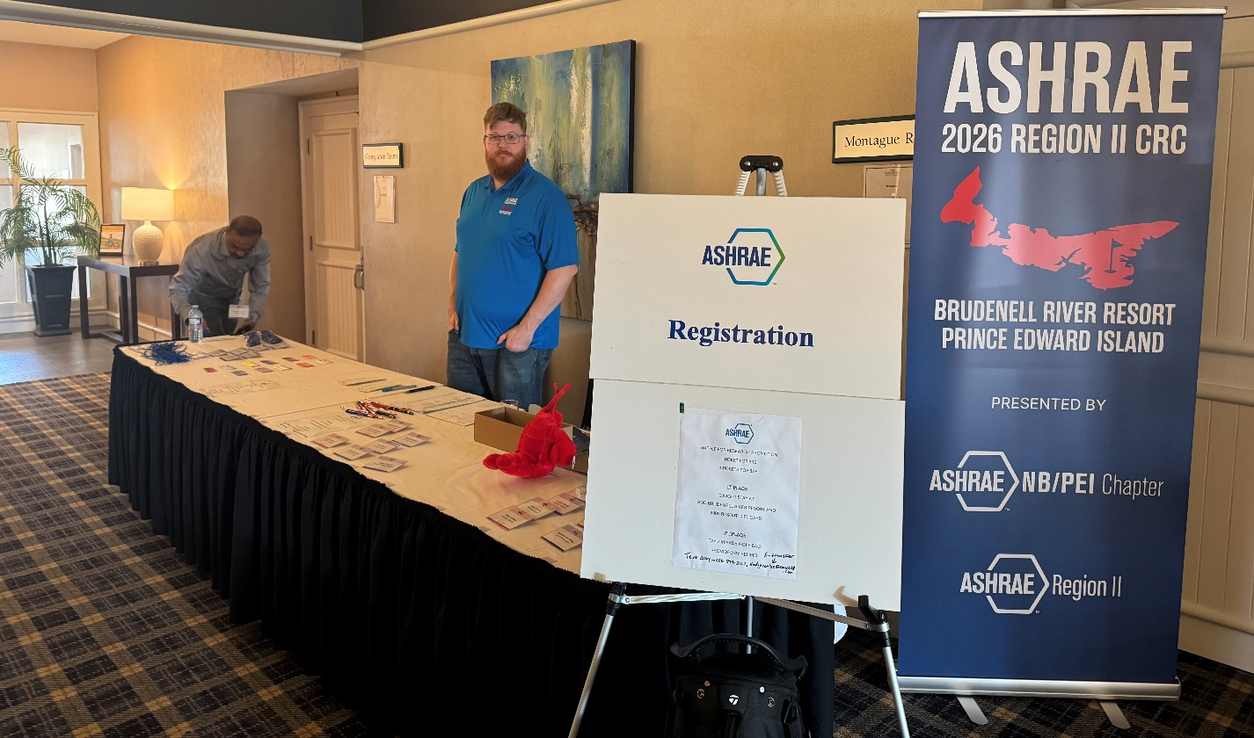
Registration at the entrance to the hotel.

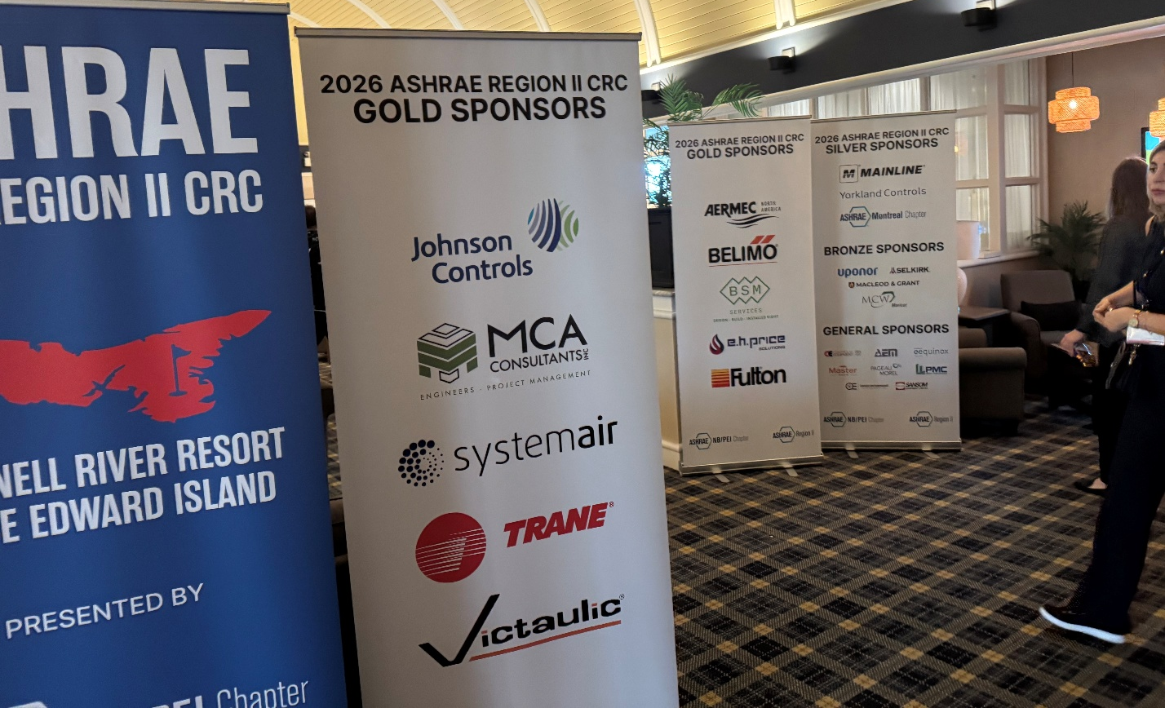
Sponsor Banners. These could be moved around as needed for events.
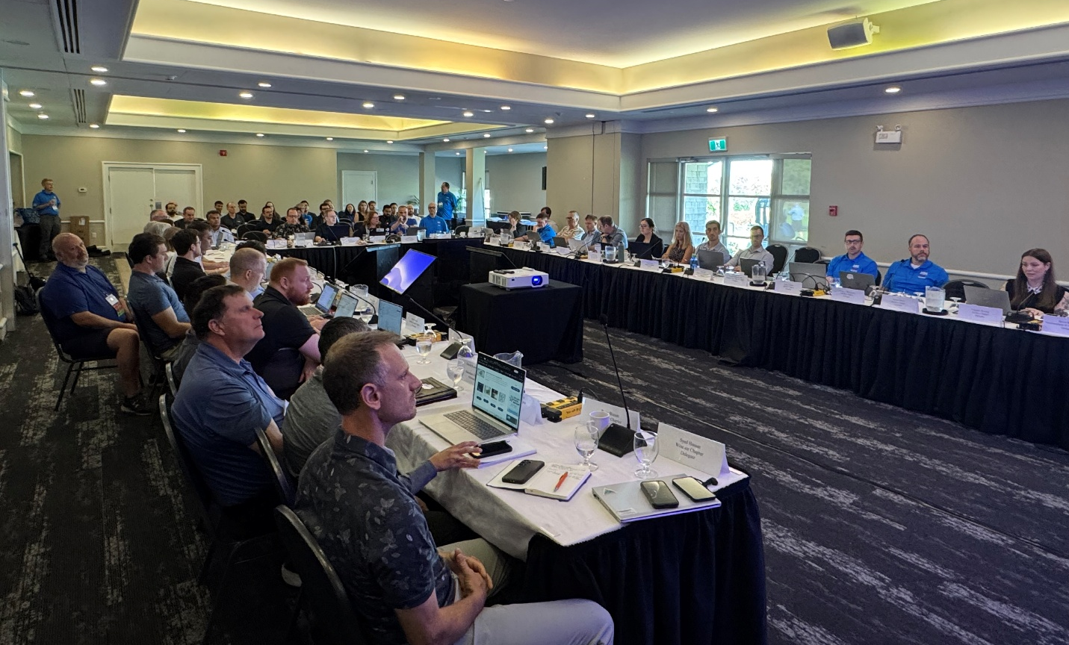
Business Session Set Up – From the Front of the Room

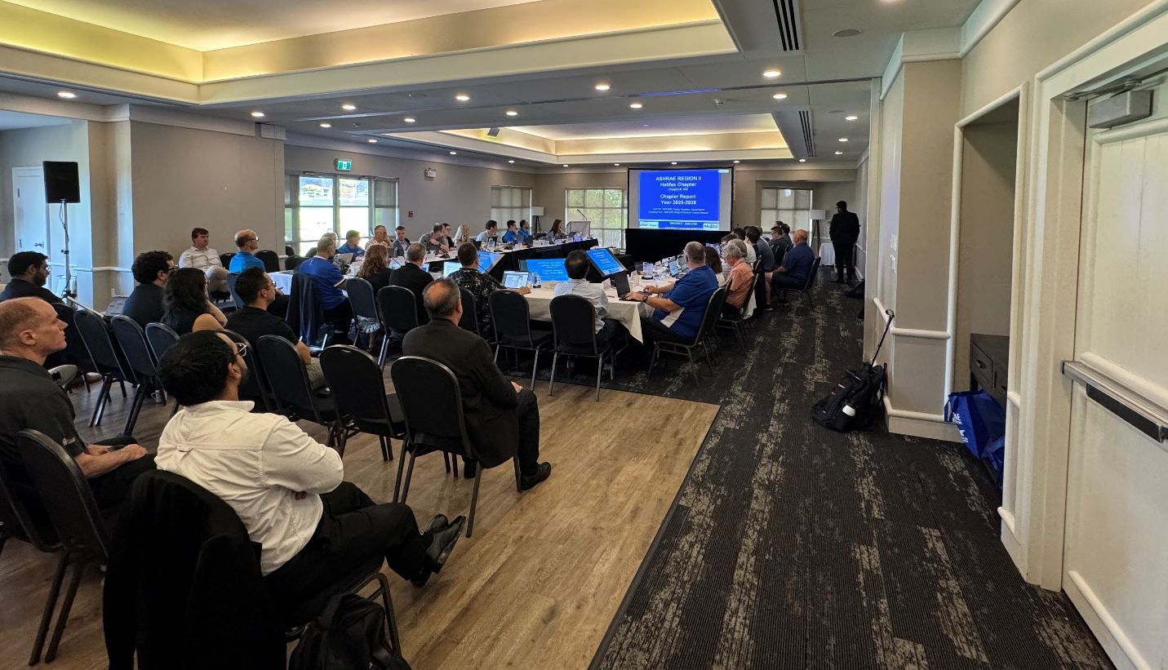
Business Session Set Up – From the Back of the Room

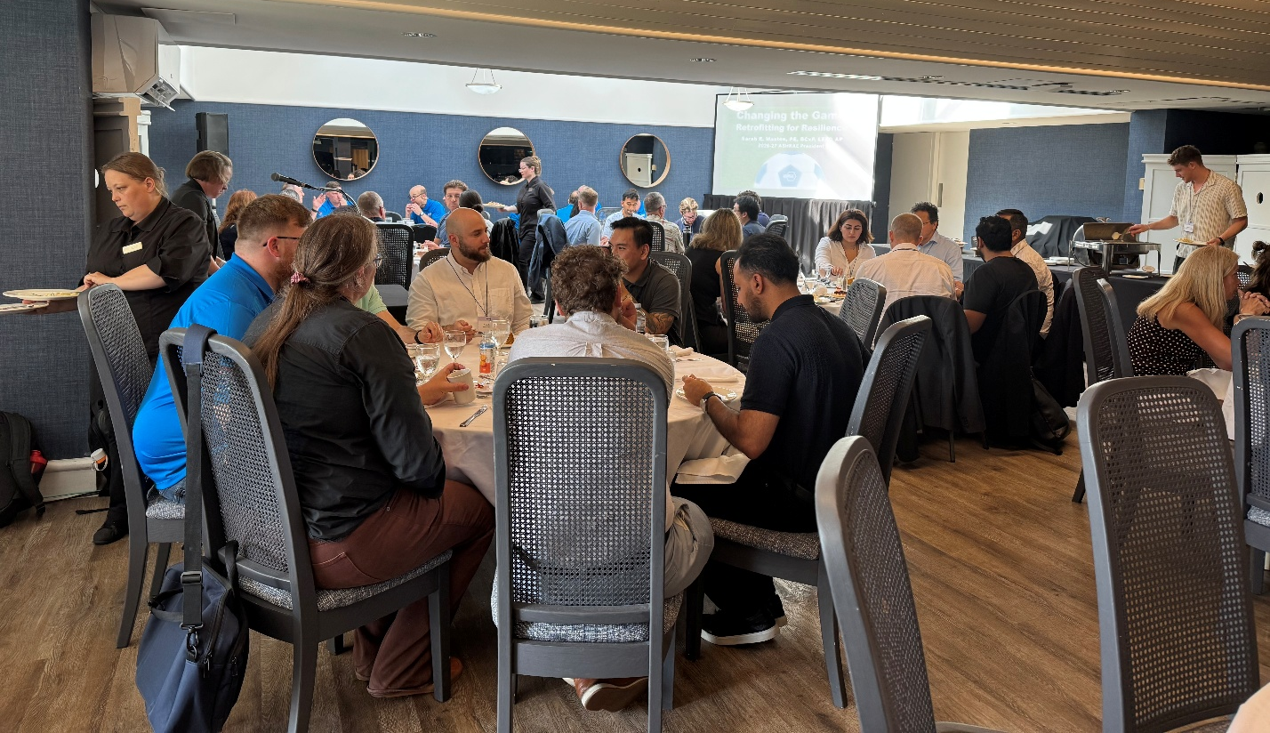
Presidential Lunch

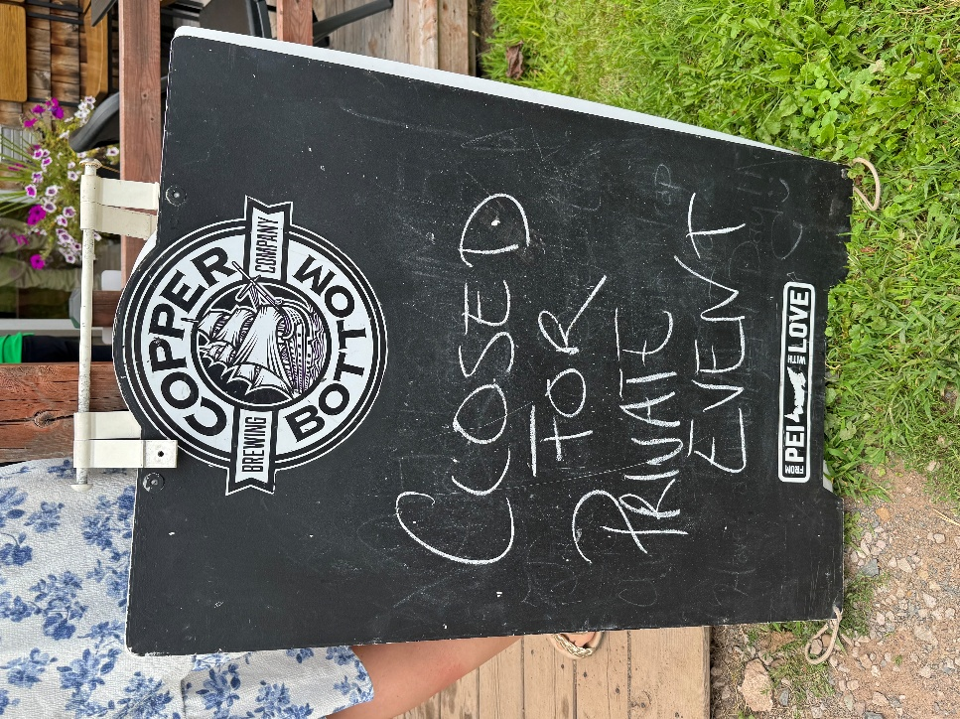
Welcome Party
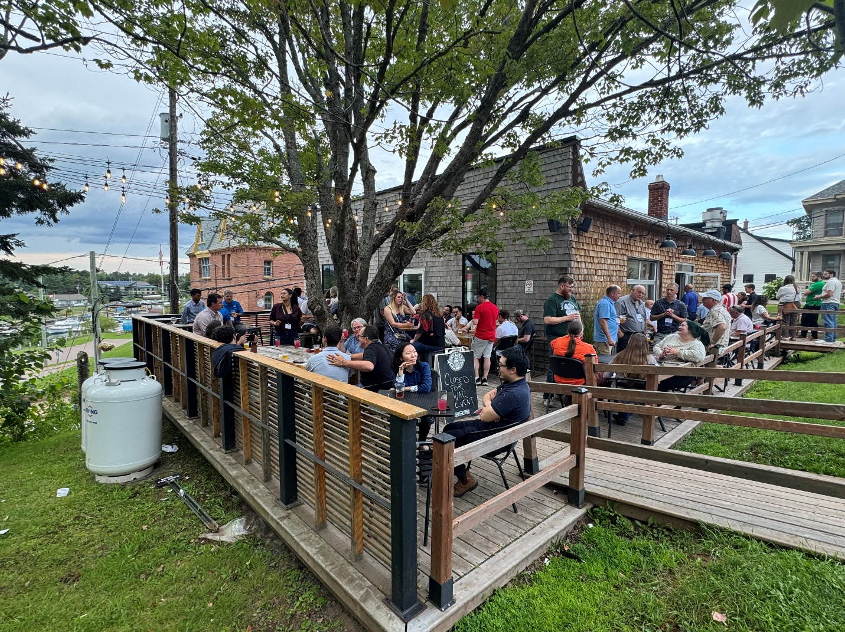
Welcome Party – Outdoor Deck

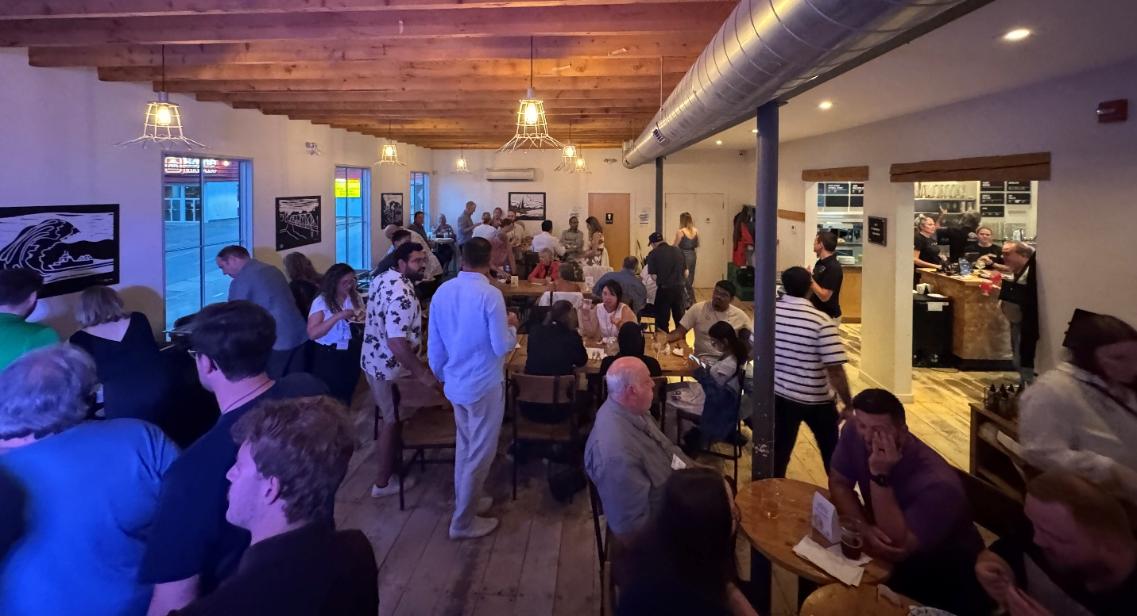
Welcome Party – Indoor Seating

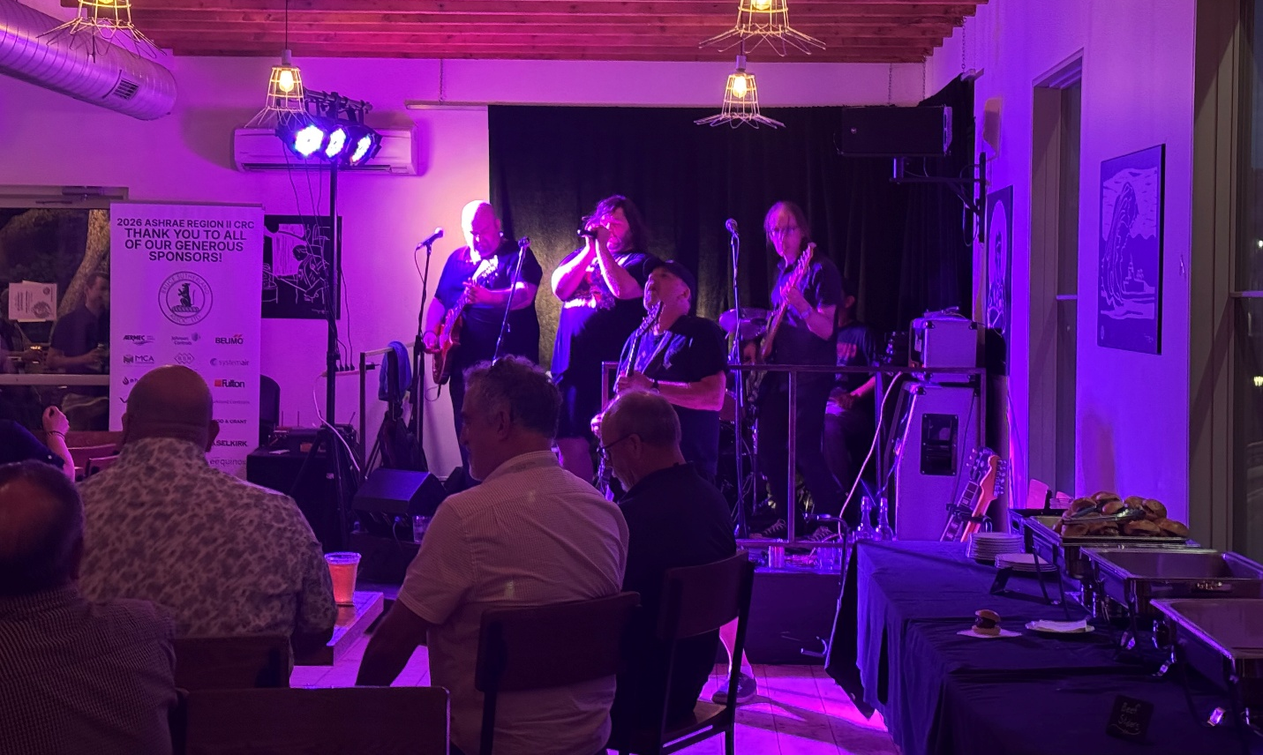
Welcome Party – High Voltage PEI (AC/DC Cover Band)

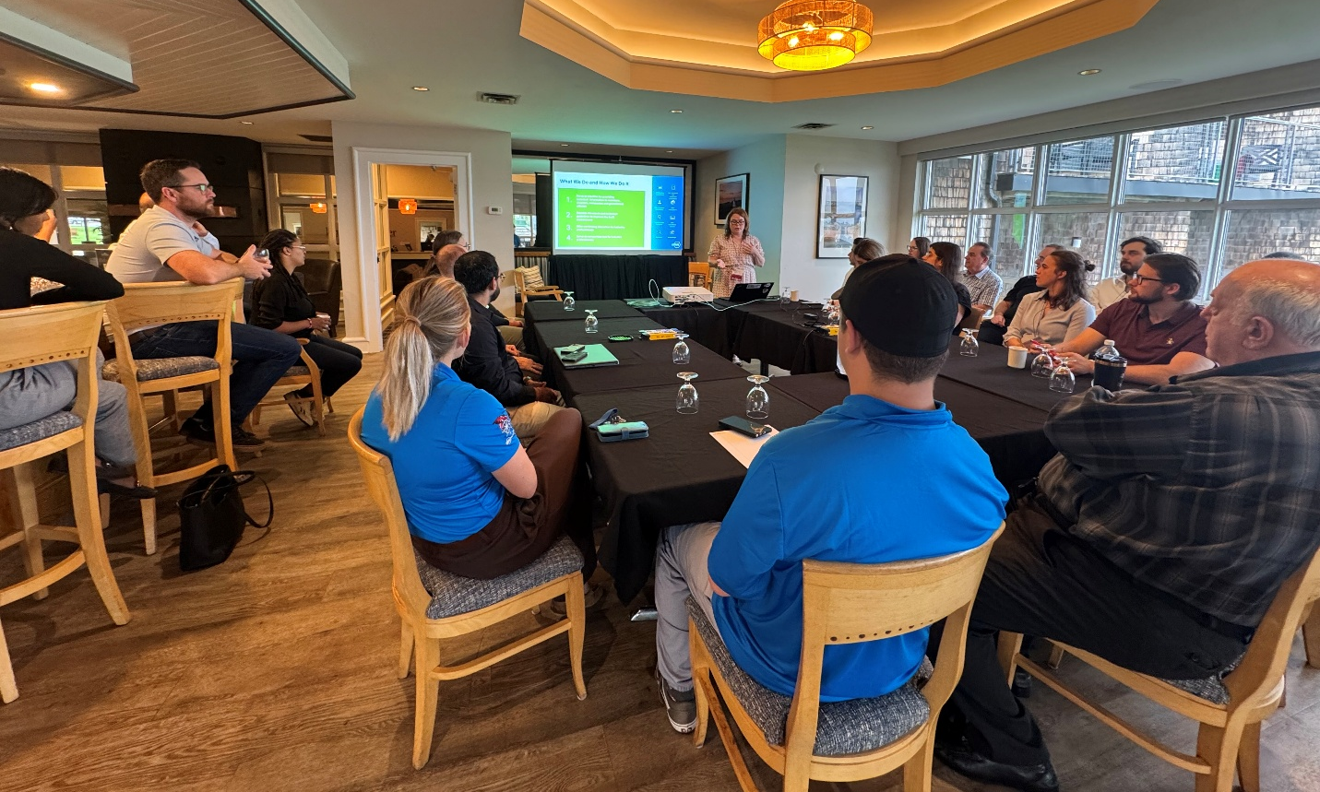
ASHRAE 101 Workshop

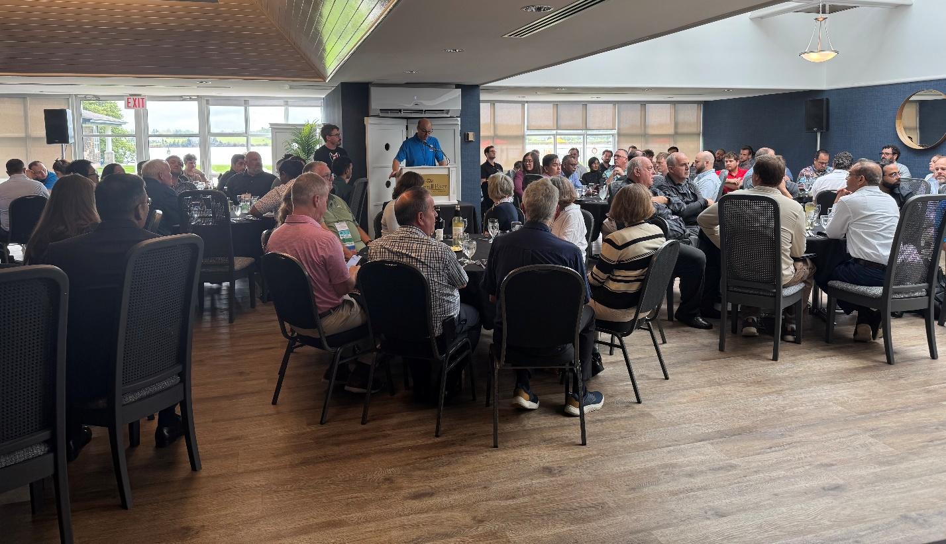
Awards Luncheon

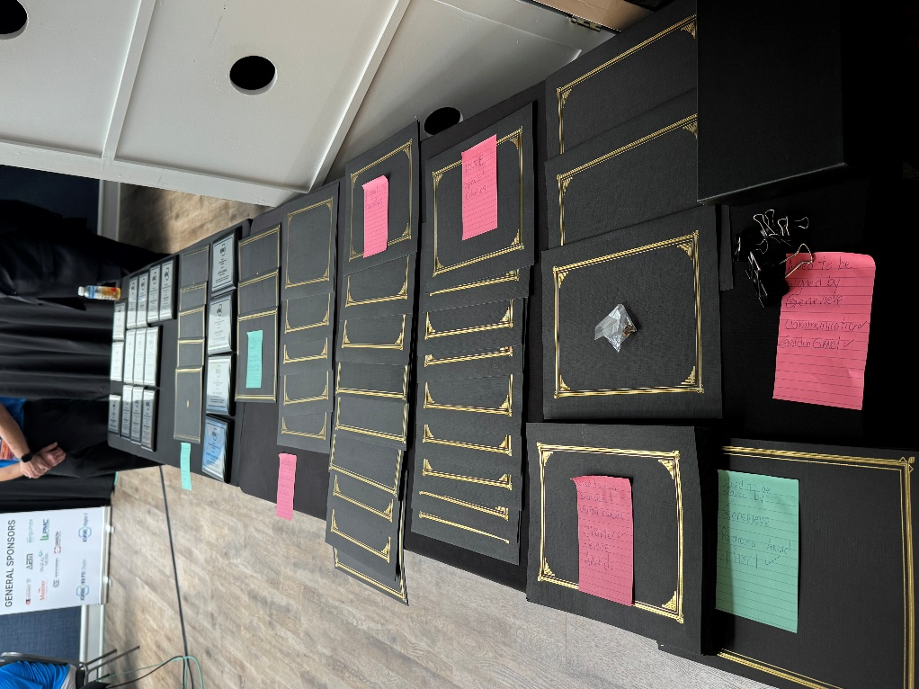
Awards Luncheon – Awards Ready to be Presented

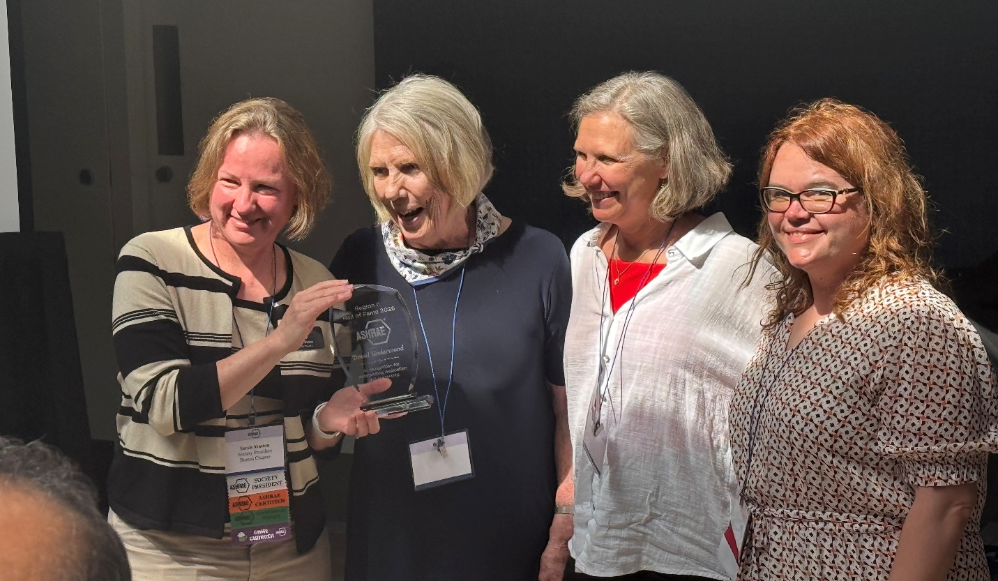
Awards Luncheon – David Underwood Region II Hall of Fame
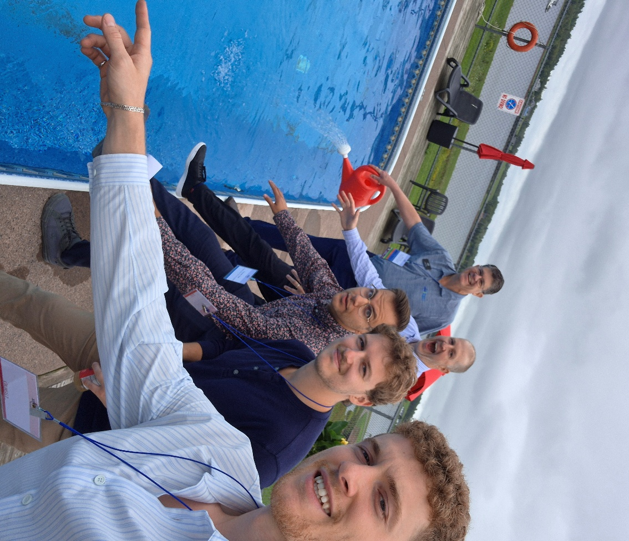
Scavenger Hunt – Outdoor Pool Clue

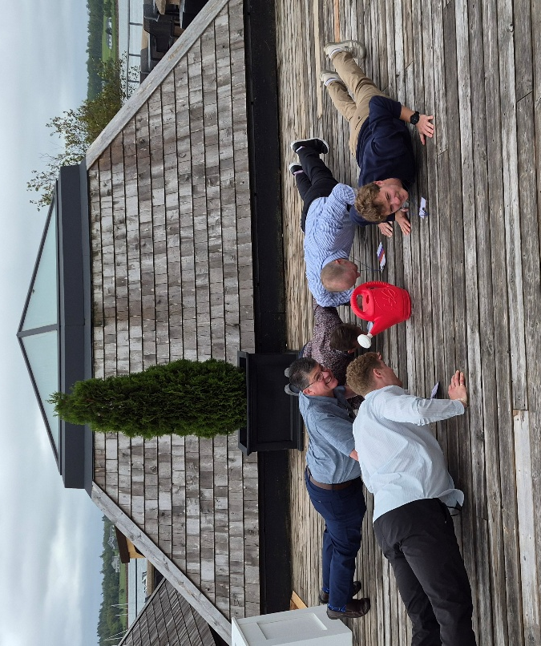
Scavenger Hunt – Push Ups Clue
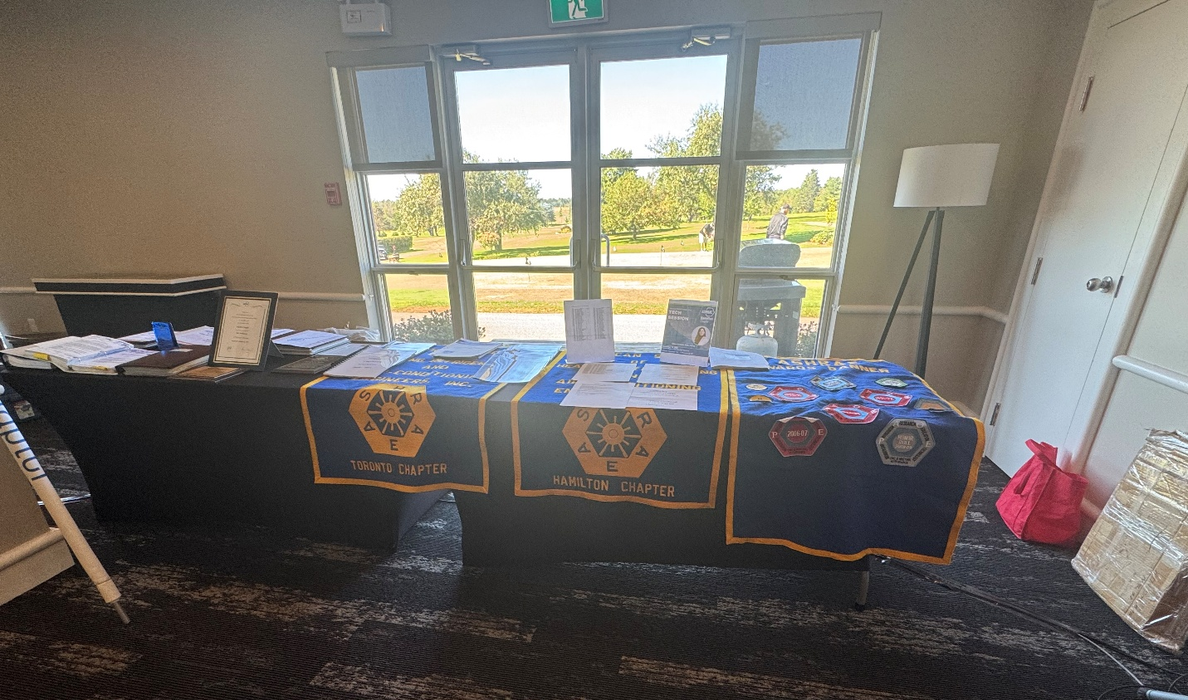
Historical Displays

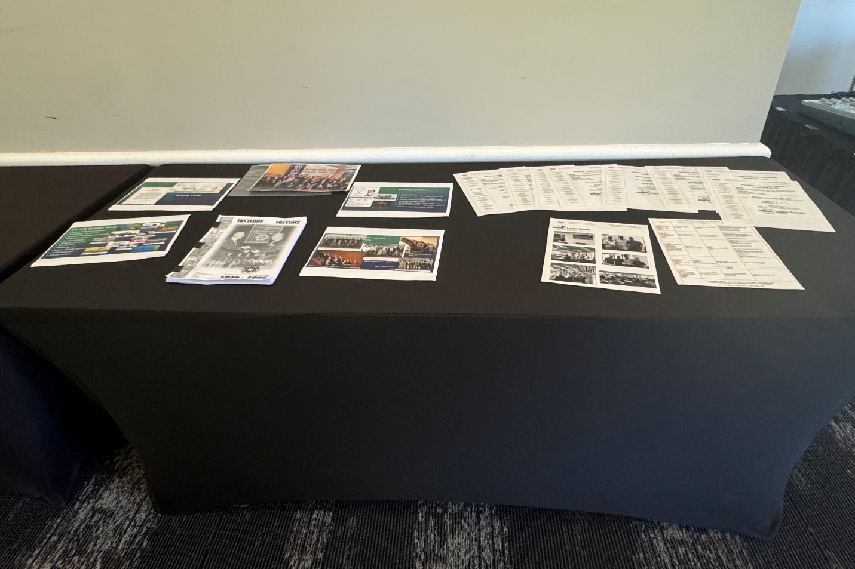
Historical Displays
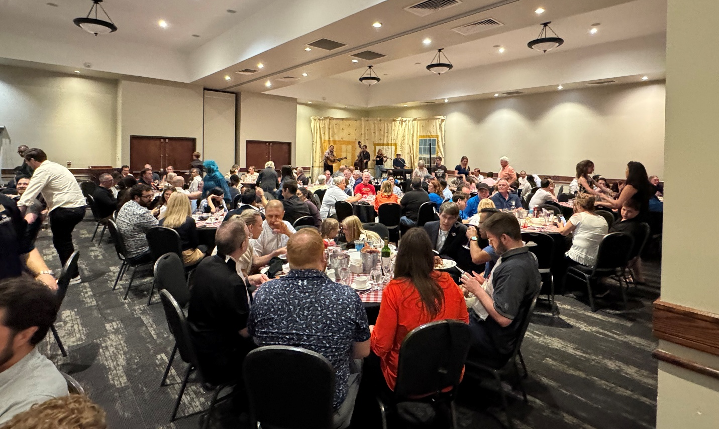
Fire In the Kitchen

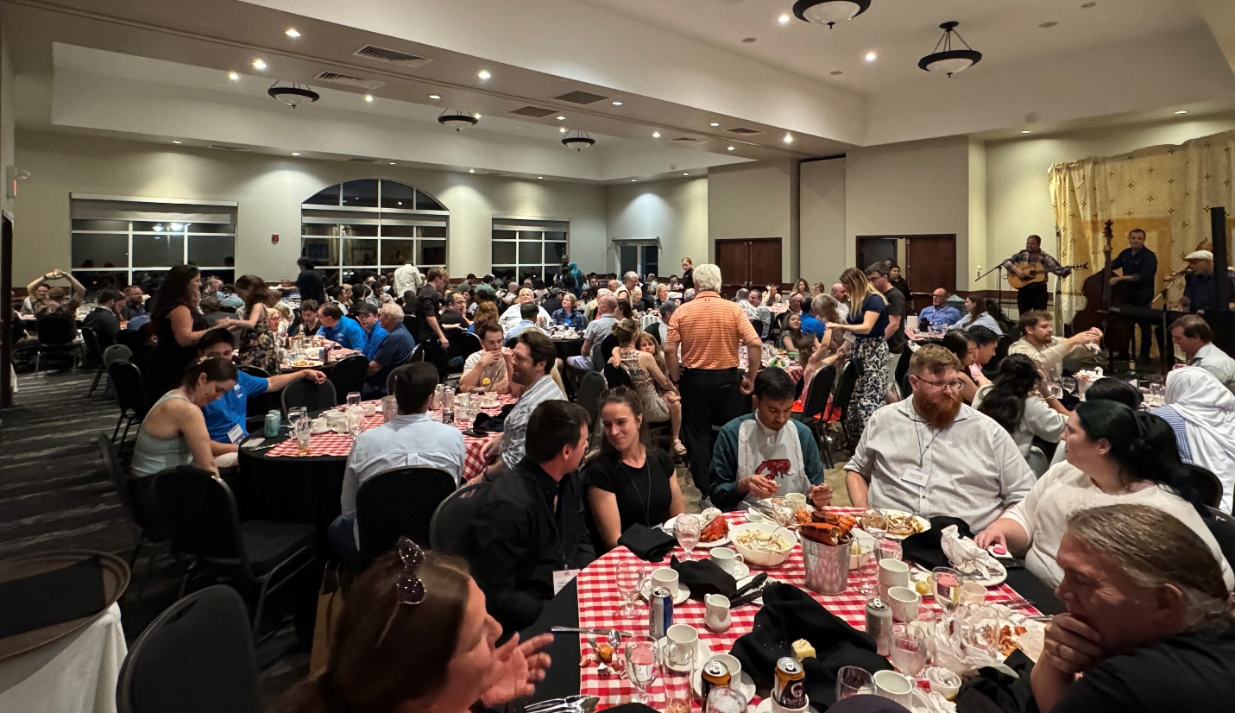
Fire In the Kitchen

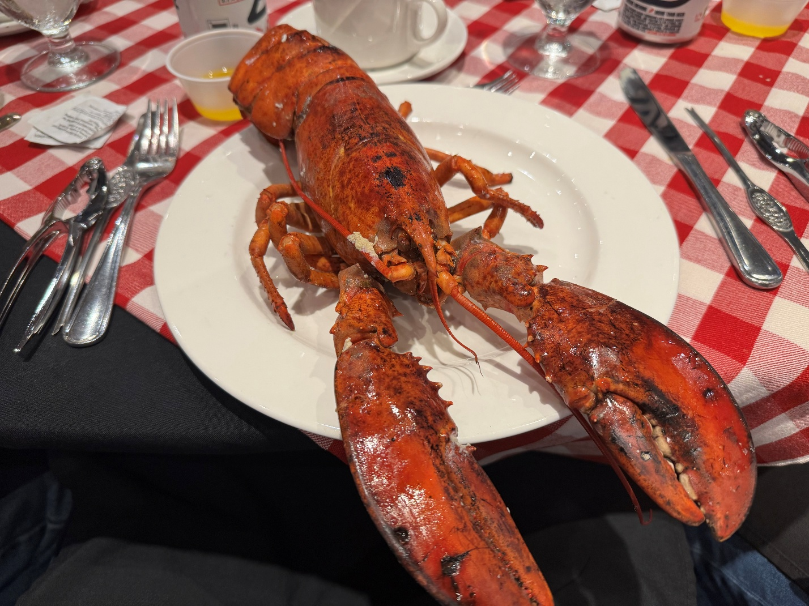
Fire In the Kitchen Dinner

Respectfully submitted,

Blake Ellis
Vice President

CRC Wrap Up Notes
August 30, 2026

Attendees:
- Jason Alphonso, Region XII DRC
- Dan Boudreau, 2026 CRC General Chair
- Karin Boudreau, Wife of Dan Boudreau
- Mike Boudreau, Region II CTTC RVC, and NB/PEI Chapter Member
- Darryl Boyce, Presidential Member
- Blake Ellis, Vice President
- Ron Gagnon, Chapitre de Montréal Member (2027 CRC Location)
- Carrie Kelty, Region VII DRC
- Isabelle Lavoie, Chapitre de Montréal Member (2027 CRC Location)
- Geneviève Lussier, Region II DRC
- Nicolas Lemire, Chapitre de Montréal Member (2027 CRC Location)
- Sarah Maston, ASHRAE President
- Tom Pollard, CRC Secretary
- Ibrahim Semhat, Region II RMCR
- Craig Wright, ASHRAE Director of Finance and Administration

Good Items from the CRC:
- AC/DC cover band on Friday night.
- Details have been taken care of, including transportation.
- The flow from one event to the next was smooth.
- Scavenger Hunt was fun!
- Loved the Maritime Way, cool, fun and casual.
- The venue and location were excellent.
- Cultural experience, including kayaking on the river.
- The companion program was busy and well planned.
- The number of chapter officers and committee members attending business sessions and other events.
- The Fire in the Kitchen dinner on Saturday night was great.
- Maritime hospitality.
- The local and regional teams gelled.
- The CRC is done!
- Families that attended the CRC.

Items to be Improved from the CRC:
- Last-minute switching of meeting rooms.
- Tightening the agenda.
- ASHRAE 101 could have been done before the conference.
- Attendance at the Sunday morning session.
- Treasurer training needs to be 90-120 minutes, rather than the planned 60 minutes.
- Add the concept of a motion workshop. There was time spent on wordsmithing motions in the business meeting that could have been addressed in a motion workshop.
- The bus got stuck under the canopy!
- Combine the chapter and RVC reports into one PowerPoint to eliminate switching back and forth.
- Have a written (printed out) plan of the site and agenda
- The room where we had the presidential address didn’t have the space needed.
- Keeping the conversations engaged and on topic when discussing motives.
- No vegetarian meals.
- The room downstairs was tough. (This is the room where the Presidential Luncheon and Awards Luncheon were held.)
- Start early on fundraising.
- Provide à la carte pricing for extras.

Notes from the CRC General Chair:
- CA$133k was the CRC budget; revenue ended up being CA$140k - CA$150k. The remote CRC caused issues because it didn't see the space. The CRC team came over only once to save money, but a second trip might have been useful.
- AV costs were on budget at CA$10,000, maybe a monitor
- Ordering materials from ASHRAE was hard.
- The insurance was difficult to deal with for the water event. (companion event)
- The main sponsor was secured during the Toronto CRC at CA$10,000. The sponsors' banners were only CA$225.
- The swag bag was covered by the sponsors.
- A total of CA$47,500 was raised in sponsorship.

